Project Planning Phase
Project Planning Template (Product Backlog, Sprint Planning, Stories, Story points)

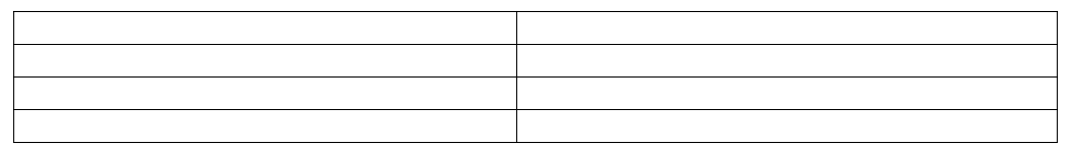
Date TeamID
Project Name Maximum Marks
24 February 2026 LTVIP2026TMIDS73033
Educational Organisation using ServiceNow 5 Marks


Product Backlog, Sprint Schedule, and Estimation (4 Marks)
Use the below template to create product backlog and sprint schedule
Sprint-2
Client Scripts
USN-5
Sprint-2
Client Scripts
USN-6

USN-7
As a developer, I can auto-populate form fields
using onChange script.
As a developer, I can implement pincode automation using client scripts.
As a teacher, I can calculate total marks using onChange script.
As an admin, I can configure process flow for
admission status.
3
High
Member 5
3
Medium
Member 1
Sprint-2
Logic & Result
5
High
Member 2
Sprint-2
Workflow
USN-8
3
Medium
Member 3

Sprint | Functional | User Story | User Story / Task | Story Points | Priority | Team
 | Requirement (Epic) | Number |  |  |  | M embers

Sprint-1  Sprint-1 | Instance Setup  Table Creation | USN-1  USN-2 | As a developer,I can request and configure a ServiceNow PDI.  As an admin, I can create Salesforce table and | 2  2 | High  High | Member 1  Member 2
 |  |  | define columns.
Sprint-1 | Table Creation | USN-3 | As an admin, I can create Admission table with choice fields. | 3 | High | Member 3
Sprint-1 | UI Design | USN-4 | As a developer, I can design form layout for  Salesforce & Admission. | 3 | Medium | Member 4


Sprint-3 | Progress Table | USN-9 | As an admin, I can create and configure Student  Progress table. | 2 | Medium | Member 4
Sprint | Functional Requirement (Epic) | User Story Number | User Story / Task | Story Points | Priority | Team  M embers
Sprint-3 | UI Design | USN-10 | As a developer, I can design form layout for | 2 | Low | Member 5
 |  |  | Student Progress.
Sprint-3 | Testing | USN-11 | As a tester, I can validate data flow and field | 3 | High | Member 1
 |  |  | automation.
Sprint-3 | Final Touches | USN-12 | As a developer, I can prepare screenshots and | 3 | Medium | Member 2
 |  |  | demo report.

Sprint | Total Story Points | Duration | Sprint Start Date | Sprint End Date (Planned) | Story Points Completed (as on Planned End Date) | Sprint Release Date (Actual)
Sprint-1 | 10 | 5 Days | 5 Feb 2025 | 9 Feb 2025 | 10 | 9 Feb 2025
Sprint-2 | 14 | 5 Days | 10 Feb 2025 | 14 Feb 2025 | 14 | 14 Feb 2025
Sprint-3 | 10 | 5 Days | 15 Feb 2025 | 19 Feb 2025 | 10 | 19 Feb 2025

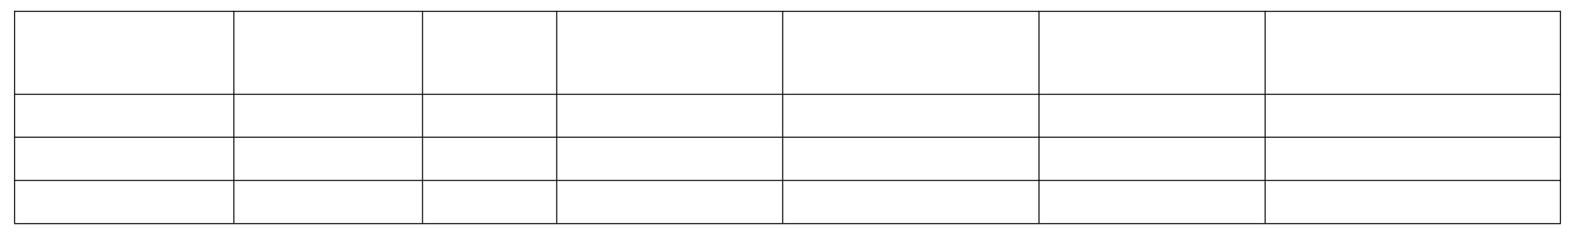
Velocity Calculation
Project Tracker, Velocity & Burndown Chart: (4 Marks)
Total Story Points = 10 + 14 + 10 = 34 Number of Sprints = 3

Velocity = 34 / 3 = ~11.3 Story Points per Sprint Burndown Chart
You can create your Burndown Chart using Visual Paradigm Online or in Excel using: X-axis: Days (e.g., Day 1 to Day 5 for each Sprint)
Y-axis: Remaining Story Points
Line 1: Ideal Progress (Straight diagonal drop)
Line 2: Actual Progress (based on story points completed each day)

